**Project Meeting Agenda**

**Meeting Agenda 4**

Date: November 7th

Meeting purpose:

Start time: 10:00am

Expected end time: 11:30am

Location: Zoom

Invitees: Dylan, Elina, David, Larry, Mbisana

**Topics**

**General Announcements.**

My team is planning to work on calculating data information for WAB buildings with solar panels. We need to find time and group up to go to the WAB rooftop to see the opinion measuring the roof space where solar panels can be installed.

Responsible for each members:

All responsible to go rooftop and measurement and check websites to see what best possible solar panels that fit.

David and Larry, will use math to calculate the solar panel that we “use” to see how much energy will get and calculate with data from the WAB building.

**Our plan for this week: November 7-13**

***Group plan:***

* Set up more on Website (Dylan)
* Need to request if they are approved to use their roof, if not, we can use their front ground to experiment.
* Finish Elevator pitch (due November 8th)
* Contact David goods for a solar panel discussion.
* work on data analysis from WAB building
* Find measurement for the rooftop.

-------------------------------------------------------------------------------------------------------------------------------

**Project Status Review**

***Dylan:***

* Update more work on a website design.
* Working on Project Proposal
* Working on figure out spaces of WAB rooftop

**Result:**

My result of updating the website is:

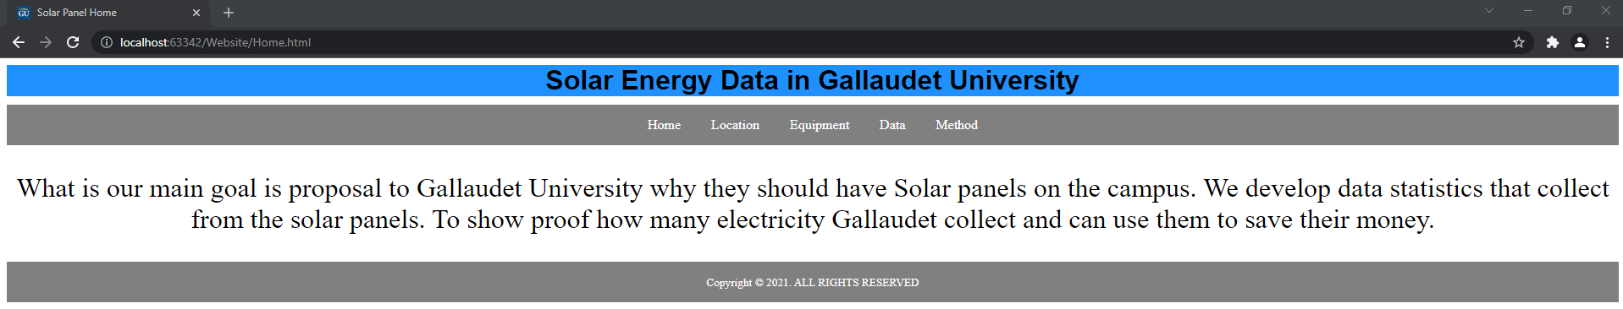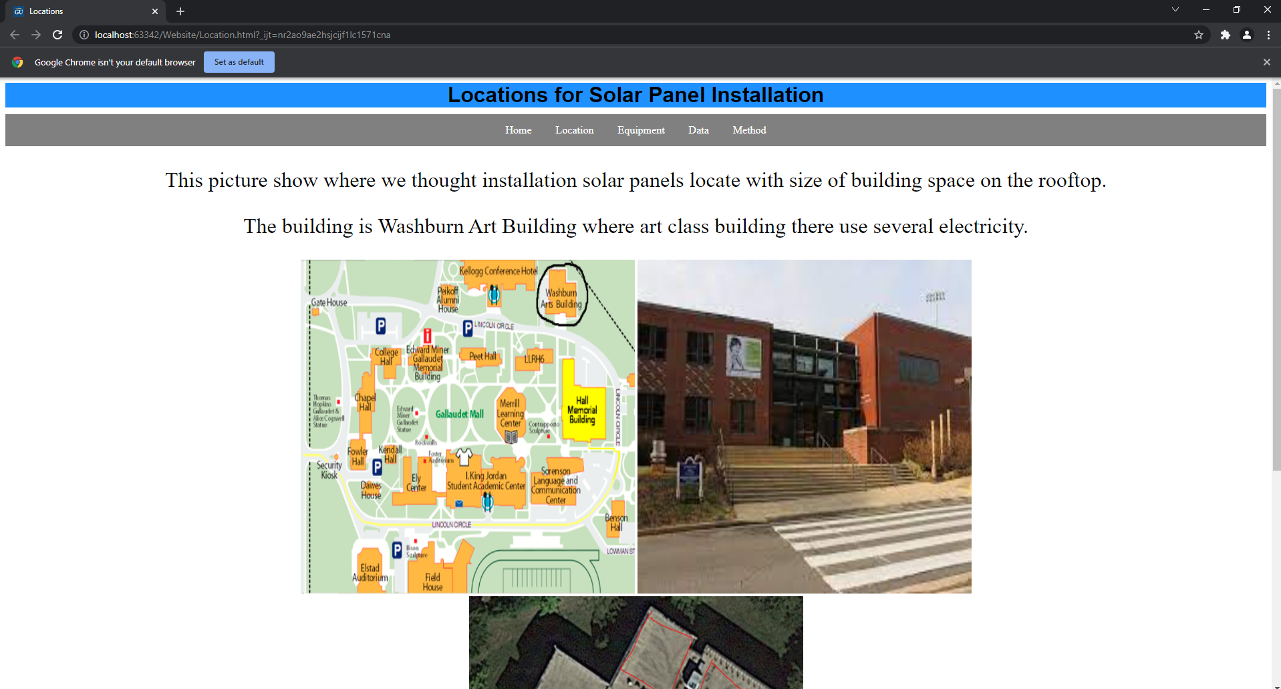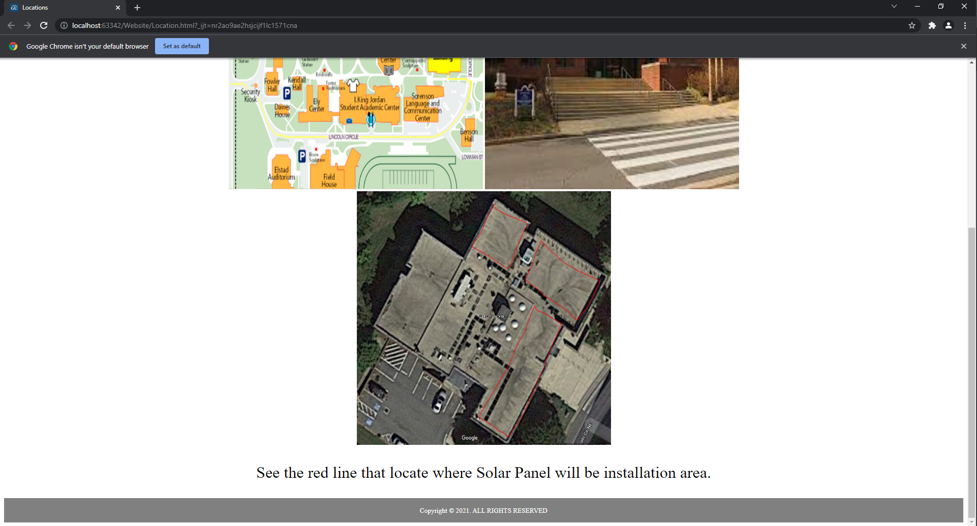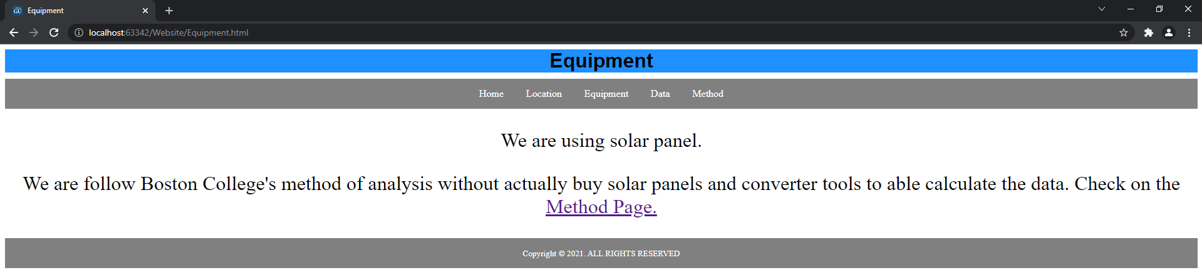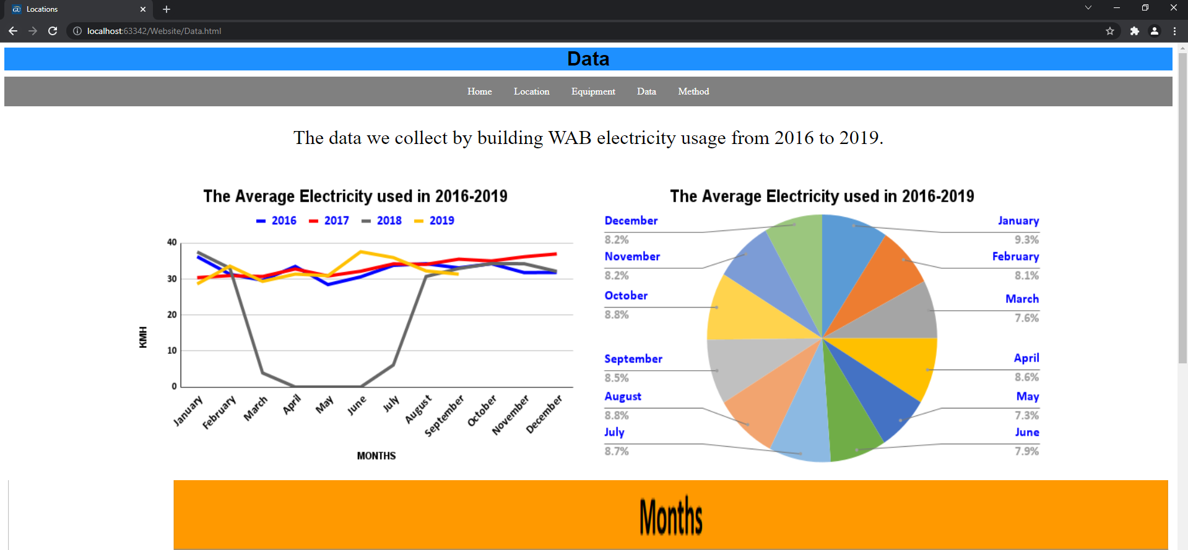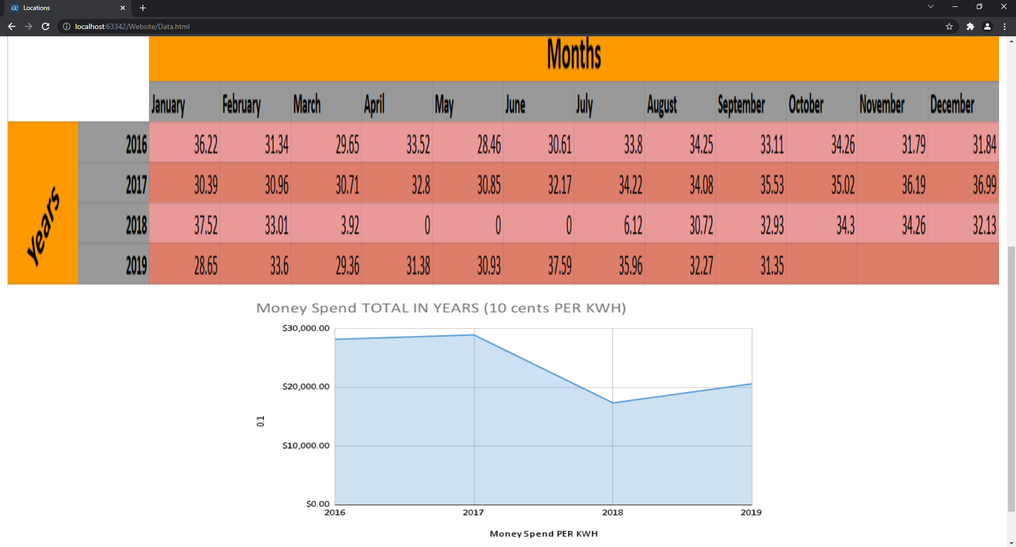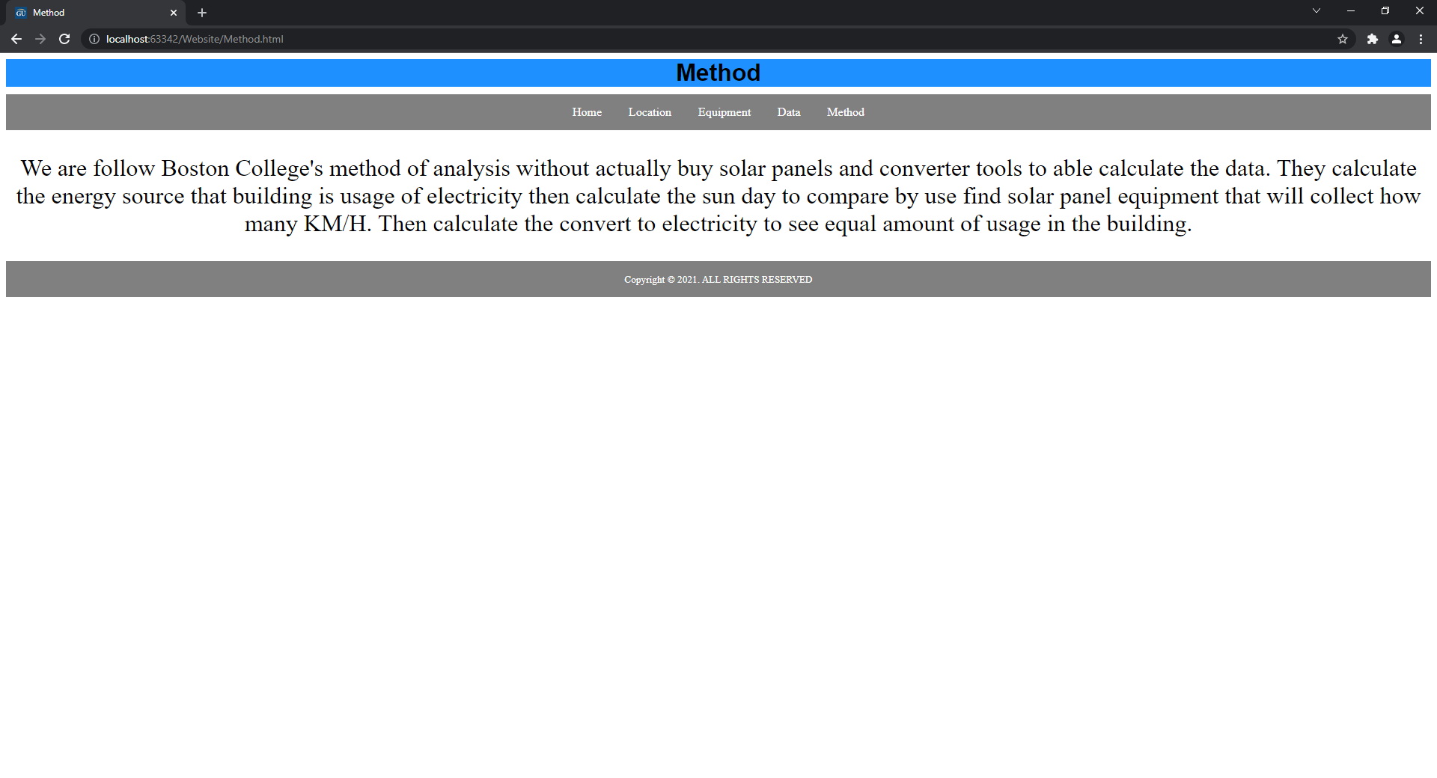

I did work on project proposals, majors responsible for the abstract, background, and Preliminary results.

Picture of WAB rooftop from google maps: (red line: locate where installation solar panel)

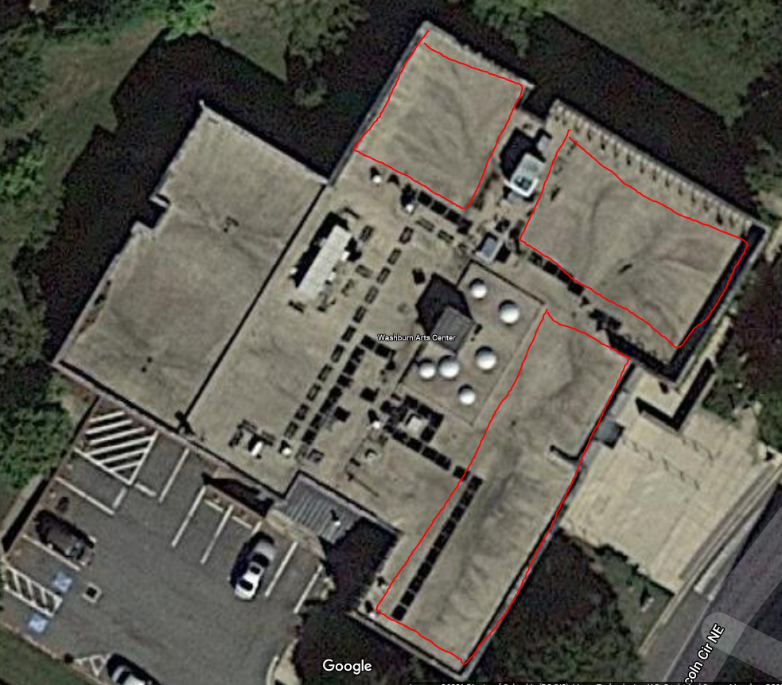

Solar panels roof from KIPP school to use this to observation. 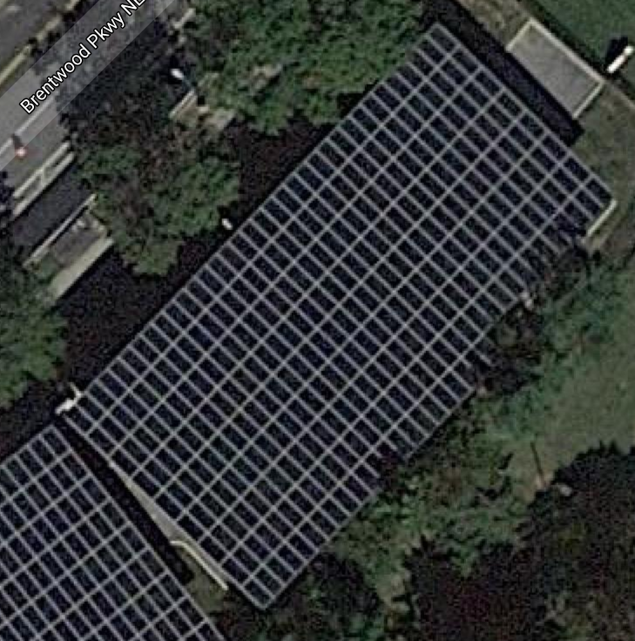

***Elina:*** Unsure how much solar panels can be installed on the WAB building since there are 3 spots where the company can install the solar panels but how many?? unsure Will email David Good and ask for his second opinion

**Result:** Just emailed him, waiting on his response

***Mbisana:***  I emailed one of stuff in WAB professor to do interviews with him and help the group summarize the data received from David Good. David asked permission from DPS so that we can go measure and observe where to install solar panels in the WAB Building.

**Result:** I didn't receive a response from the Professor to do an interview so I will do a follow up with him. David, Larry and I went to measure and observe the top building of WAB. We measured two areas, one had 16ft width and 32ft length, the other had 17ft width and 51ft length so we decided to pick the one with 17ft width and 51ft length because it has more space and the surface is flatter compared to the other. I managed to help the group by analyzing the data and making tables and graphs then uploading them in our project proposal.

|  |  |  |  |  |  |  |  |  |  |  |  |  |  |
| --- | --- | --- | --- | --- | --- | --- | --- | --- | --- | --- | --- | --- | --- |
|  | | **Months** | | | | | | | | | | | |
| **January** | **February** | **March** | **April** | **May** | **June** | **July** | **August** | **September** | **October** | **November** | **December** |
| **Years** | **2016** | 36.22 | 31.34 | 29.65 | 33.52 | 28.46 | 30.61 | 33.8 | 34.25 | 33.11 | 34.26 | 31.79 | 31.84 |
| **2017** | 30.39 | 30.96 | 30.71 | 32.8 | 30.85 | 32.17 | 34.22 | 34.08 | 35.53 | 35.02 | 36.19 | 36.99 |
| **2018** | 37.52 | 33.01 | 3.92 | 0 | 0 | 0 | 6.12 | 30.72 | 32.93 | 34.3 | 34.26 | 32.13 |
| **2019** | 28.65 | 33.6 | 29.36 | 31.38 | 30.93 | 37.59 | 35.96 | 32.27 | 31.35 |  |  |  |

The table shows the average watts taken every month each year from 2016 to 2019.

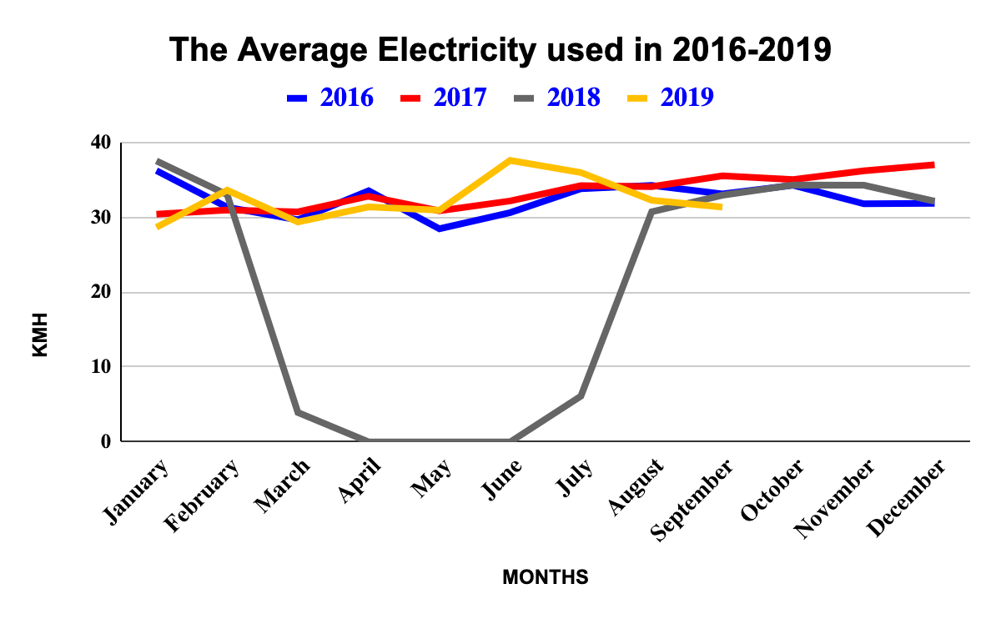

The graph shows a linear graph showing the visual data of watts used every month of each year from 2016 to 2019.

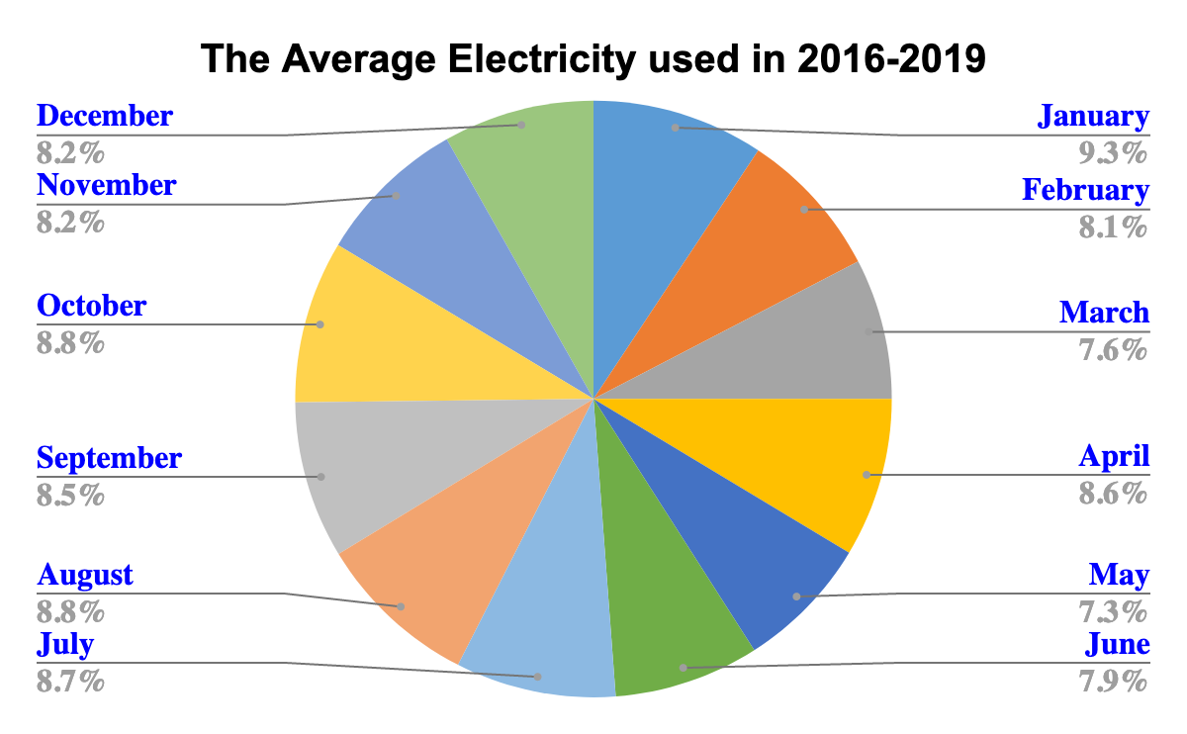

The chart shows the Pie graph of the electricity used in each month for four years in percentage.

***Larry:*** The problem appears is the budget that costs from electricity is approximately ten cents per kWh. We have approximately 200-400 kwh. Therefore, the electricity costs around ($20-40?) per month. It depends on which light bulb they are using (regular or LED) if it is LED, which is an appropriate measurement of the electricity they are using and the costs too. Will double check and follow up with David Good on Monday, 11/8/2021.

**Result:** Received an email from David Good-

The building has predominantly fluorescent lighting fixtures. Fluorescent lighting fixtures is a low-pressure mercury-vapor gas-discharge lamp that uses fluorescence to produce visible light. An electric current in the gas excites mercury vapor, which produces short-wave ultraviolet light that then causes a phosphor coating on the inside of the lamp to glow. Fluorescent lamps, including compact fluorescent lights (CFLs), use about 75 percent less energy than incandescent bulbs and last six to 15 times as long, according to the U.S. Department of Energy (DOE).

Fluorescent Lighting fixtures are usually used to provide illumination for settings such as commercial lighting, industrial lighting, classroom lighting, and retail lighting.

***David:*** I went to WAB because I wanted to see the roof for my project Solar Panel. Leslie Southwell and said they were unsure whether to allow the roof. I gave my email to them. They sent the rooftop of the WAB building and Khadijat Rashid sent it to me too. I was sent to DPS because I should allow the rooftop of the WAB building. I was not hearing from DPS. I decided to go to the DPS office. they said, they checked an email. They should meet me at WAB. I saw the rooftop. I picked 3 places on the rooftop. I measured the place. Mbisana, Larry and I went to see the rooftop of the WAB building.

**Result: I saw 3 places on the rooftop. I looked at websites with 4 different sizes.**

[**https://www.cleanenergyreviews.info/blog/most-powerful-solar-panels**](https://www.cleanenergyreviews.info/blog/most-powerful-solar-panels)

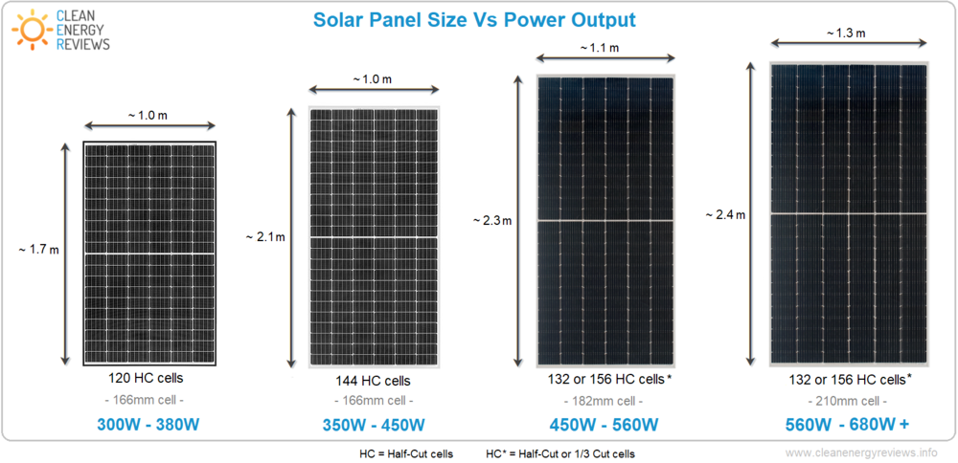

I took a camera and measured 5.0 m, which was bigger than size’s solar panel. all sizes can be put on the rooftop. Which is to pick one size for a solar panel. Different 3 places are 17 ft, 34 ft, and 51ft.

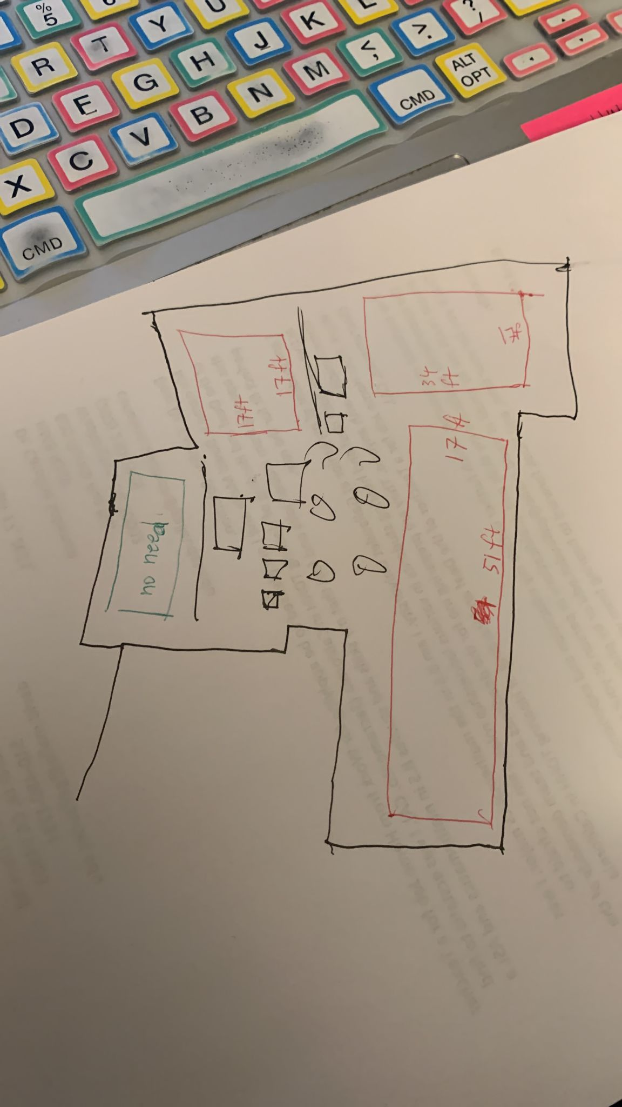

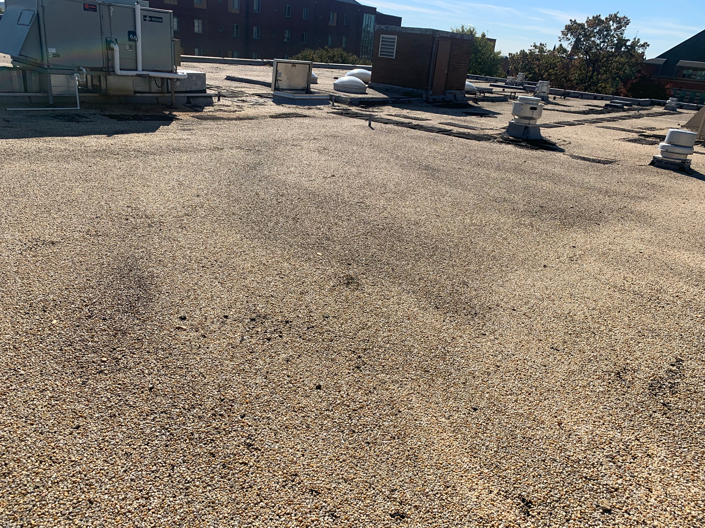

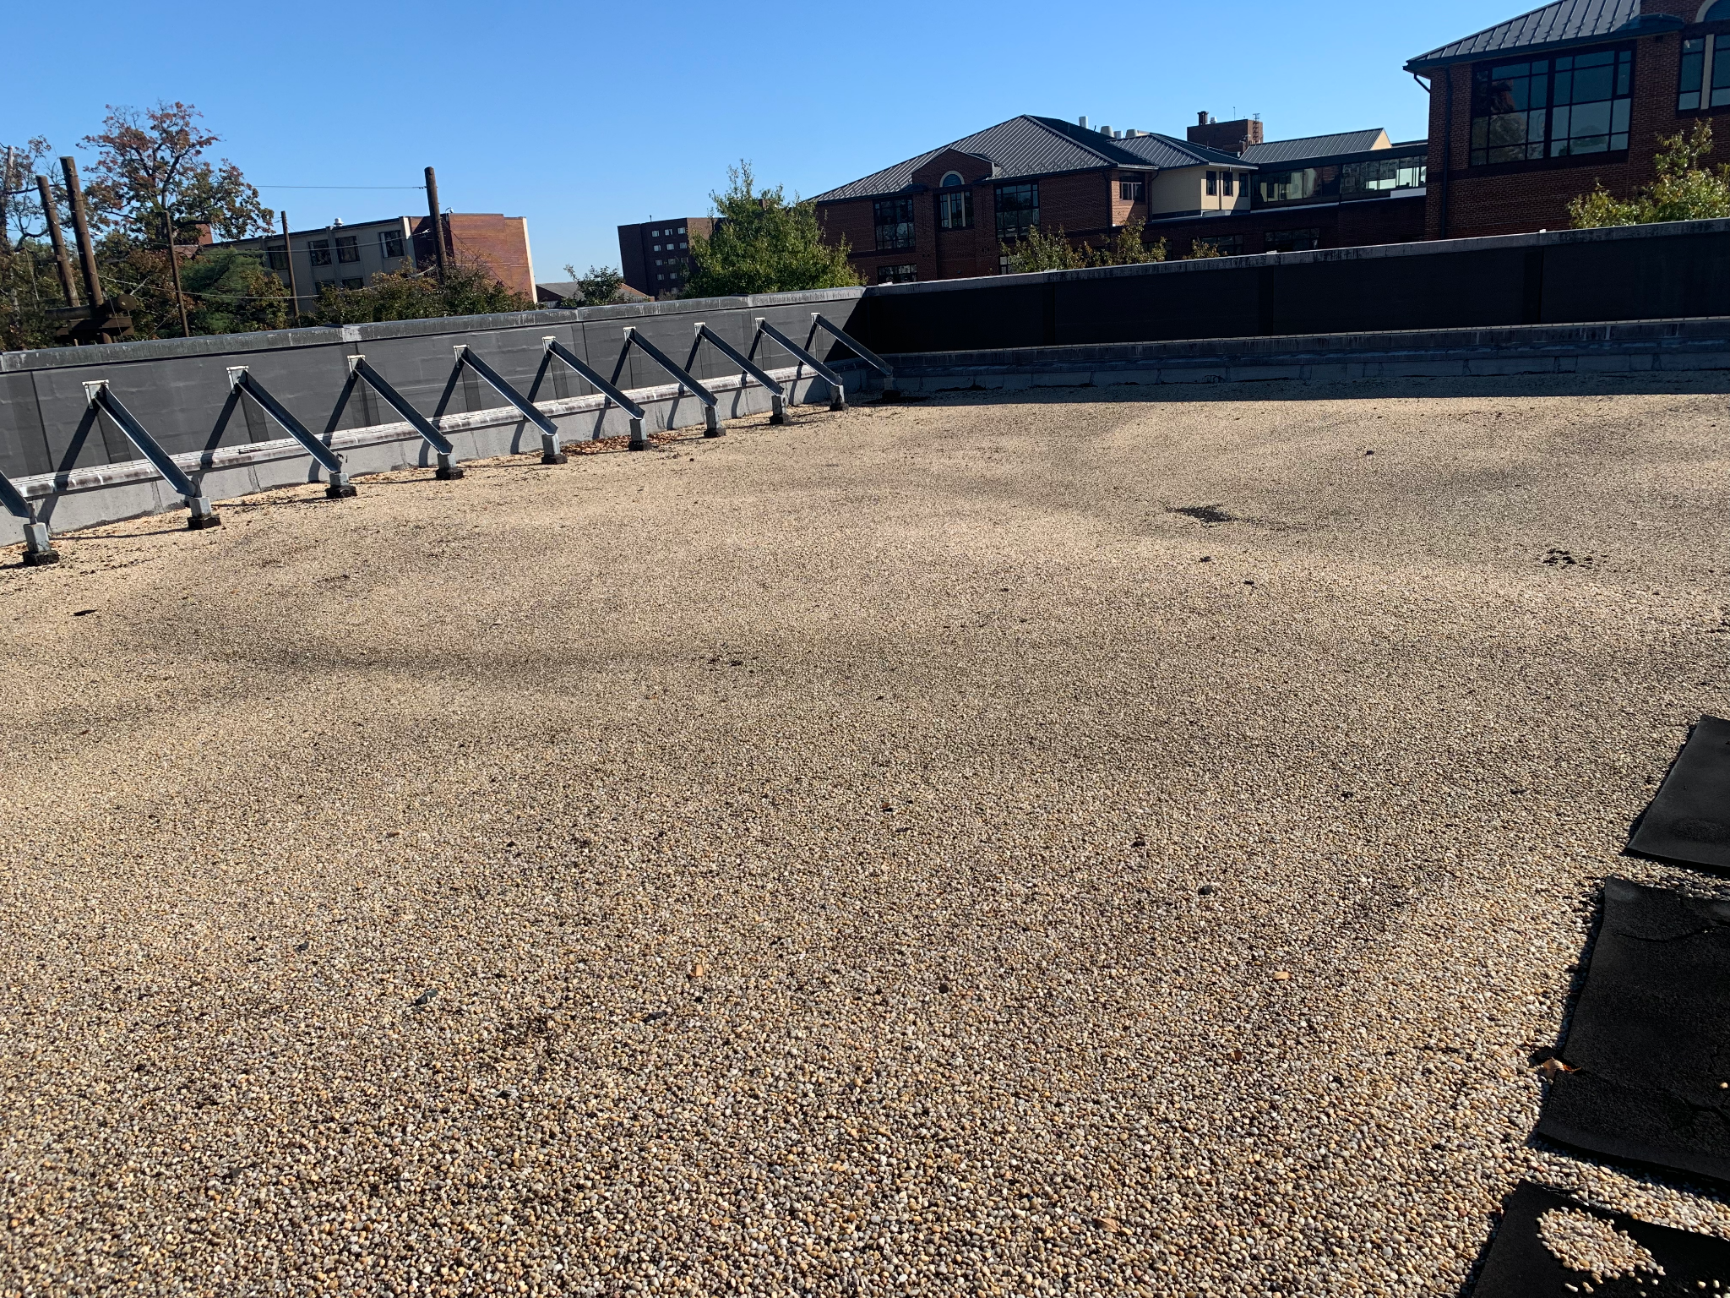

-------------------------------------------------------------------------------------------------------------------------------

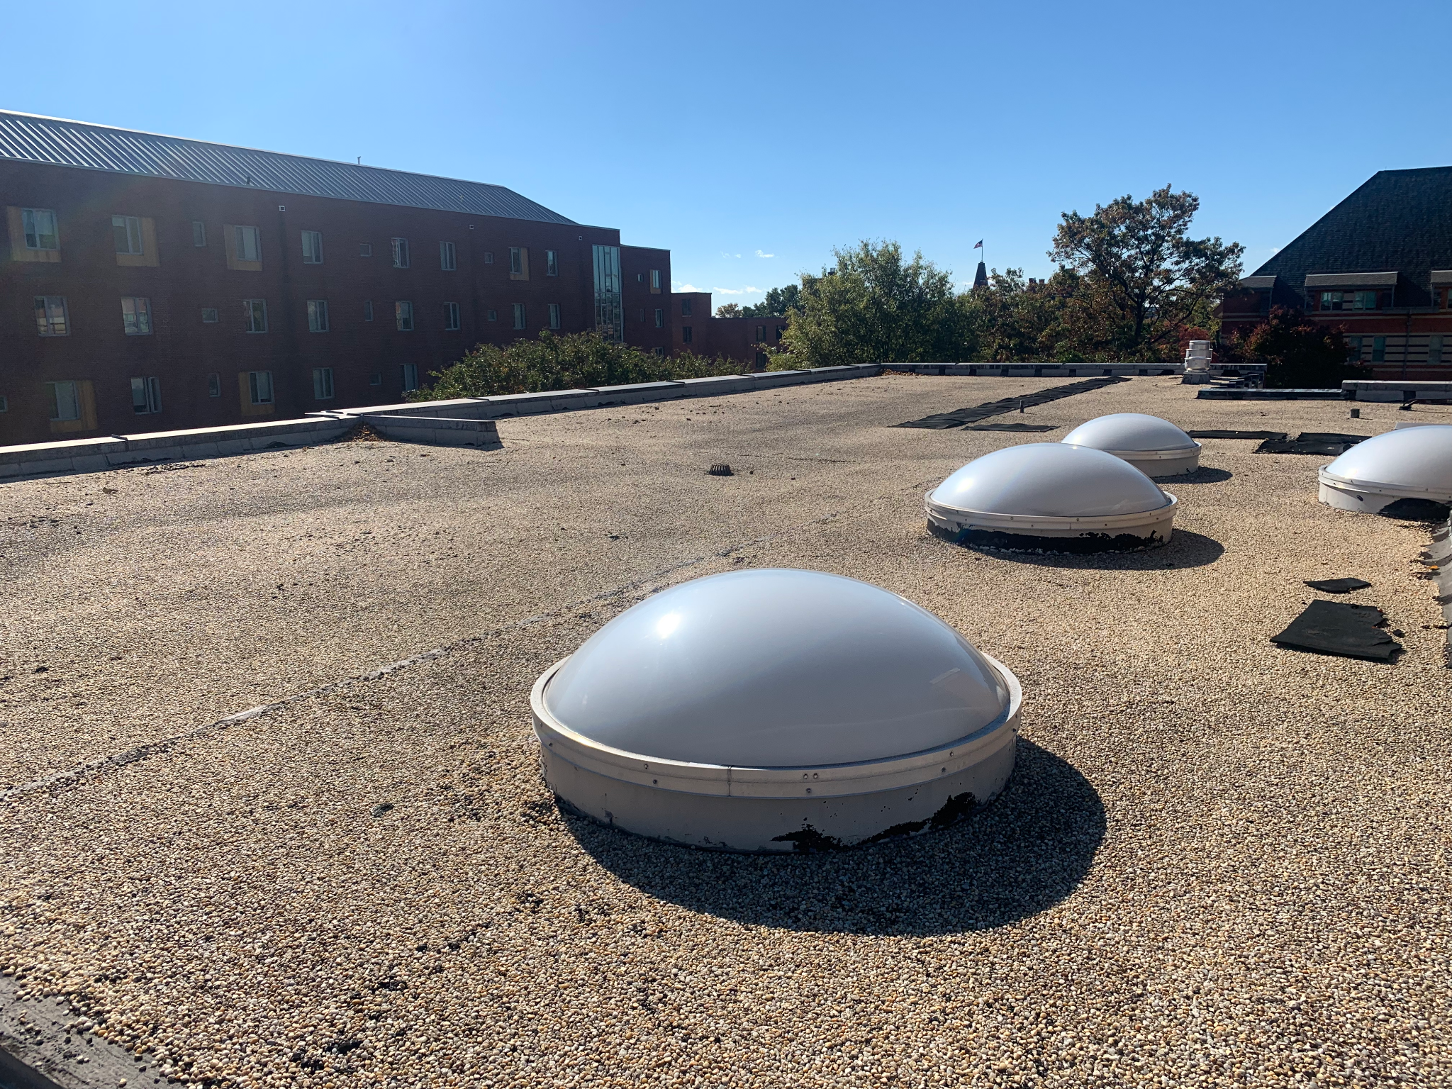

Our meeting report on November 7, 2021.

We are discussing Elevator Pitch and our project proposal.

**Our Weeks plans:**

|  |  |  |
| --- | --- | --- |
| Week | To do List | Complete? |
| October 24 Week | * Finalize find and order tools for solar panels * Set up more on Website (Dylan) * Need gather data of electricity usage of WAB building * Need to request if they are approved to use their roof, if not, we can use their front ground to experiment. * Start on Project Proposal | * Yes and no * Yes and no * Yes * No * Yes |
| October 31 Week | * Meeting report #4 * Hopefully get tools then set up tools start the data * Finish Project Proposal (Due Nov 9) * Discuss Elevator Pitch | * Yes * No * Yes * Yes |
| November 7 Week | * Project demo 1 show how collect and my website idea * Analyze data |  |
| November 14 Week | * Conunitne analyze data * Hopefully we can find specific data that we can find to understand why we need to use our building. |  |
| November 21 Week | * Fall Break * Meeting report #5 |  |
| November 28 Week | * Finalize Website * Finalize Data of Solar Energy and profit * Project Demo 2 |  |
| December 5 Week | * Work on Final paper? And develop our final powerpoint to show our work. :) |  |

**Our new issue needs to look at:**

What size we need to figure out related to the solar panel for the WAB building. Not sure what or how many panels we can install for the WAB rooftop. We need to have accurate measurements to be able to find how much.

**Concern:** Our concern is the rooftop hatch door for it is 3 ft and 5 ft but it cannot bring solar panel size that is a problem.